Financial Lit Name: _______________________

______________ _____________

WS Assessment

Target 1:

STOCK MARKET DATA

**I can:**

* Use stock data to follow the daily progress of a corporate stock.
* Writes spreadsheet formula
* Interpret, create a stock bar chart, a stock candlestick chart.

**Unit 1 Math Topics:**

* Fractions, decimals and percent
* Linear equation
* Literal equation
* Mean – Arithmetic average
* Percent increase, decrease
* Ratio and proportion
* Read, interpret and create bar and line graphs
* Simple moving average
* Spreadsheets and formulas

A business owned by one person is a **sole proprietorship**. The owner, or proprietor, can hire people to help run the business, but these employees are not owners. The owner is responsible for all expenses, including labor and raw materials used in manufacturing a product or providing a service. The money left after all expenses are paid is **profit**.

A business that is owned by a group of people, called partners, is a **partnership**. Partners share the profits and the responsibility for any losses. The partners are personally liable for any losses.

A corporation is a business organization that can be owned by one person or a group of people. Each owner who invests money in the corporation receives **shares of stock** in the corporation. The owners are called **shareholders**. When anyone can purchase stock in a corporation, the corporation is a **public corporation**. You might already be familiar with public corporations, such as NIKE, McDonald’s, Amazon, and Apple. The prices of shares of stock in public corporations can be found in newspapers, on television business channels, and on the Internet.

Michelle invests $15,000 in a partnership that has four other partners. The total investment of all partners is $240,000. What percent of the business does Michelle own?

Kyle invests $20,000 in a partnership that has five other partners. The total investment of the partners is $160,000. What percent of the business is owned by the five other partners?

The total number of shares of stock in the Bulls Corporation is 650,000. Mike owns 12% of the shares. How many shares of Bulls Corporation stock does he own?

Three partners are investing a total of $900,000 to open a garden and landscaping store. Their investments are in the ratio 2:3:5. How much does the partner that invested the least contribute?

Two partners are starting a wedding planning business. The total investment is $45,000. Their investments are in the ratio 4:5. How much does each investor contribute?

Stock market is a general term for an institution through which stocks are bought and sold. Stock market transactions are known as trades. The two most well known stock markets are the New York Stock Exchange (NYSE) and the National Association of Securities Dealers Automated Quotation System (NASDAQ).

In order to interpret stock market data, you need to know the meaning of the categories used in stock market international charts. (You google for the following term)

|  |  |  |  |  |
| --- | --- | --- | --- | --- |
| Last: | Close | High | Low | Volume |
| 52-week high | 52-week low | Chg or net change | After-hour trading |  |



What was the difference between the high and the low prices on May 5? _________

On May 5, what was the actual volume of XYZ shares posted? _________ On May 12? __________

At what price did XYZ Corporation close on **May 4**?

Find the difference in prices as a percent increase when stock opening on May 5.

Find the difference in prices as a percent increase when stock opening on May 12.

Open google docs – spreadsheet enter the following <http://bit.ly/2zyua5F>

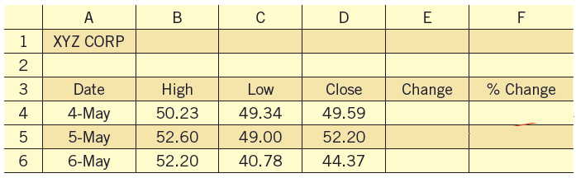

Find the Change and % Change on May 5

Find the Change and % Change on May 6 (Show me for stamp) -15%

Enter the following spreadsheet into your google docs. <http://bit.ly/34cKhEb>

Use formula to fill in the blank. Stamp



Stock bar chart

Open =

Close =

High =

Low =

Volume =

Base on the Ford’s Stock bar chart, create a Ford daily spreadsheet

|  |  |  |  |  |  |  |
| --- | --- | --- | --- | --- | --- | --- |
| Ford Daily | Date | High | Low | Open | Close | Volume |
|  |  |  |  |  |  |  |
|  |  |  |  |  |  |
|  |  |  |  |  |  |
|  |  |  |  |  |  |
|  |  |  |  |  |  |

Candlestick Charts

Another type of chart that is similar to a stock bar chart is a candlestick chart. A candlestick chart may be easier to read and contains more information at a glance.

The top and bottom of the vertical line indicate the high and low prices over the given time period.

The rectangular region is known as the

real body and is displayed in two different colors depending upon the action for the day on that stock.

Base on the this candlestick chart, create a spreadsheet

|  |  |  |  |  |  |  |
| --- | --- | --- | --- | --- | --- | --- |
| Ford Daily | Date | High | Low | Open | Close | Volume |
|  |  |  |  |  |  |  |
|  |  |  |  |  |  |
|  |  |  |  |  |  |
|  |  |  |  |  |  |
|  |  |  |  |  |  |

**Assessment Target 1**

**I can…** interpret, create a stock bar chart, a stock candlestick chart and write spreadsheet formula





Base on the chart, create a spreadsheet data for at least 5-day of your favorite stock

<https://www.barchart.com/stocks/quotes/AMZN/interactive-chart>

Or use the one below Show me for stamp

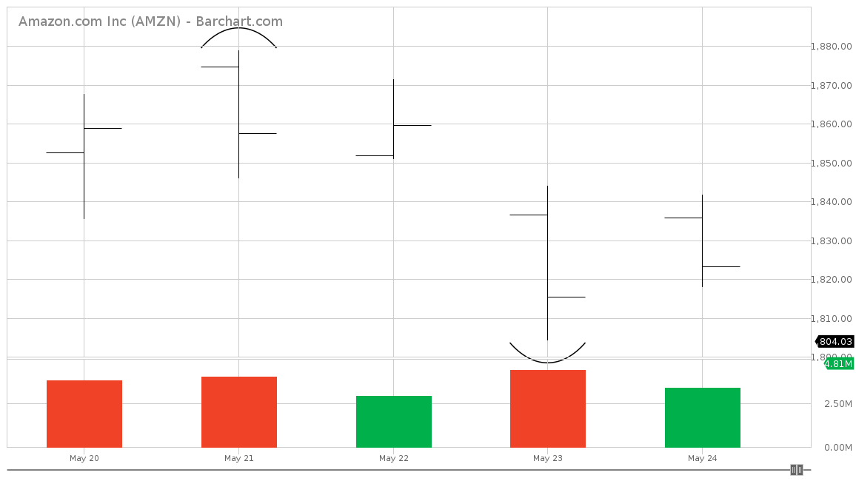

| Date | Open | High | Low | Close | Volume | Change | % Change |
| --- | --- | --- | --- | --- | --- | --- | --- |
| May 20 |  |  |  |  |  |  |  |
| May 21 |  |  |  |  |  |  |  |
| May 22 |  |  |  |  |  |  |  |
| May 23 |  |  |  |  |  |  |  |
| May 24 |  |  |  |  |  |  |  |